**Software Unit Testing Report**

**Student name: Wenjian Chen**

**Student ID: S369101**

* **Introduction**:

The objective of this project is to develop a Guess the Number game using Test Driven Development in Python. The game challenges players to guess a randomly generated 4-digit number while providing hints through 'circle' and 'x' symbols. The main requirements include generating a random 4-digit number, comparing the player's input with the generated number, counting the number of attempts, displaying hints through 'circle' and 'x' symbols, allowing players to quit the game any time play again when the game finishes.

I’ll use “PyUnit” as the automated Unit testing tool. This tool allows us to create and execute test cases to ensure the correctness of our code. It automates the process of checking whether the various components of our program are working as expected.

* **Process**:

TDD involves writing tests before writing code, ensuring that the code meets the requirements outlined by the tests. “PyUnit” can help execute these tests automatically, validating my code's correctness and detecting issues early. I repeated the process of writing tests, implementing code, refactoring till the game is developed.

1. Generate a random 4-digit number：

TDD approach: Define a test function to verify the generated number's format and length.

Implementation:

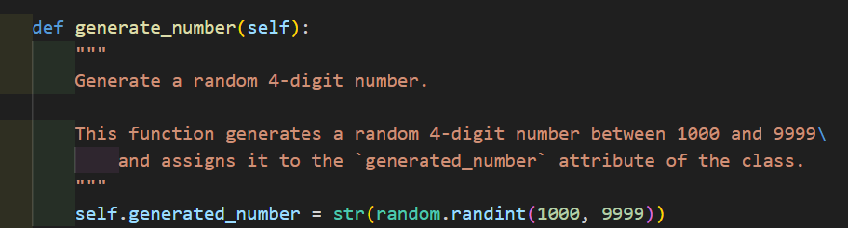

1. Compare the player's input with the generated number, provide the hints.

TDD approach: Define a test function to check if the comparison function correctly identifies the correct and wrong digits by check if “hints” are correct.

Implementation:

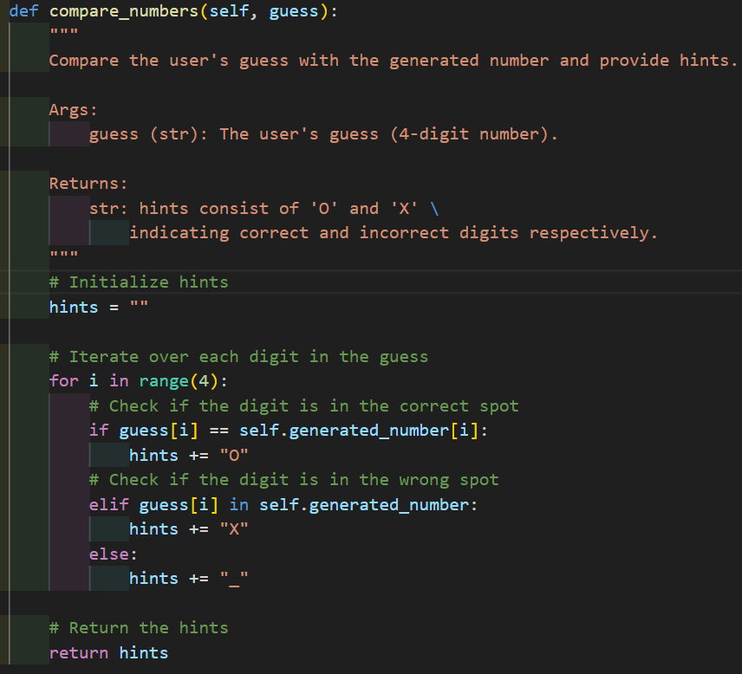

1. Play game and count the number of attempts ：

TDD approach: Define a test function to Validate that the game loop persists until the user correctly guesses, and check if the number of attempts is correct.

Implementation:

1. Allow player replay and quit:

TDD approach: Define a test function to check if game replay and quit successfully.

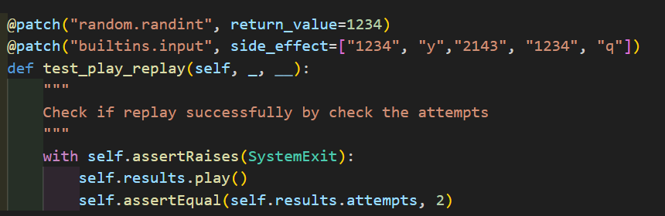

Implementation:

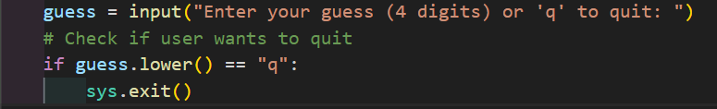

* **Conclusion**:

TDD minimizes the risk of regressions and defects, contributing to the stability of the codebase, it helps me to develop the guess number game successfully. Utilizing the “PyUnit” tool enabled automated testing, which greatly sped up verifying the correctness of the code, helped catch errors early in the development cycle. But there still have some defect in the game, such as the interface lack of aesthetic and the tips not enough. We can improve them by designing a new interface, providing more informative messages and clear instructions.

GitHub link: <https://github.com/Wenjian-Chen/PRT582_Software-Unit-Testing-Report>